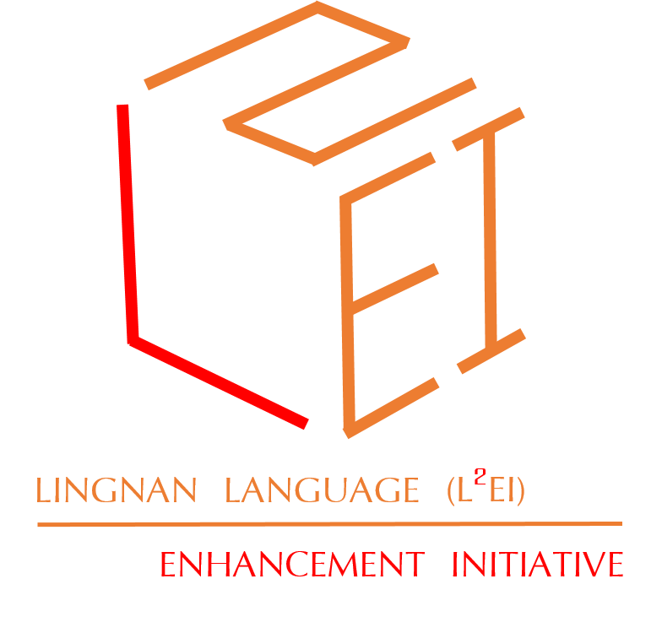
Office of Student Affairs
Student-initiated Multi-Cultural and Multi-Lingual Enhancement Programmes Campus Fund (MMCF) Programme Activity Report

Personal Information Collection Statement
1. The purpose of collecting personal data by means of this form is to evaluate the captioned programme you participated.
2. In order to serve the specified purposes the personal data collected may be transferred to relevant units within the University and/or outside parties for verification. All information provided and raw data will be destroyed by the end of academic year.
3. The personal data collected will not be disclosed to third parties other than those specified without your express approval, or unless required by law.
4. Unless indicated otherwise, all personal data requested in this form is required for its purpose(s).
5. As a data subject, you have the right to request access to and correction of the personal data under the Personal Data (Privacy) Ordinance. For such requests, please contact Office of Student Affairs at 26167309.

A. Programme Information
Title of the Programme:
Programme Start Date: |  |  | Programme End Date:
Venue: |  |  | Number of Participants:
Programme Type: | ILP-bearing Non ILP-bearing

B. Programme Activity Report
Items | Details
1. Programme Objectives
2. Learning Outcomes Achieved
(at least 150 words)
3. Brief Programme Rundown
4. Evaluation by MMCF Applicant(s) | i.) General Evaluation (please tick the appropriate boxes)  a.) Programme Rundown was smooth and effective
 | b.) Materials / Contents could arouse participants’ interest
 | c.) Participants actively engaged in language exchange
 | d.) Participants were exposed to new culture(s) for appreciation
 | e.) Programme objectives were achieved
 | ii.) Other Observation / Reflection from MMCF Applicant(s)
5. Suggestions for Improvement for Similar Programmes in Future
C. Programme Financial Report
Item | *Number of receipt(s) | Quantity | Unit Price | Total
Income
 | Total Income
Expenditure
 | Total Expenditure
Programme Surplus/Deficit
(Total Income – Total Expenditure)

Please check the following boxes before submitting the application to OSA
☐ Original receipts are attached in this application form
☐ 3 – 5 activity photos sent to OSA at mmcf@LN.edu.hk

Particulars of Applicant (or the Person in Charge (PIC) for group’s application)
Name of Hall:
Student Name: |  |  | Student ID:
Lingnan Email Address: | @LN.hk |  | Mobile number:

Signature of Person in Charge |  | Name in Full (PIC) |  |  | Date

- For Office Use

Funding is Approved Disapproved

Approved Funding Amount : |  |  |  | Remarks :
Approved by : |  |  |  | Date :

